Include in your Word doc file a program description of your app at page 1.

If in a group, include each members name and what each member accomplished!

This is the final project for ITMD 411. The project specs are to build a ticketing system that allows both the administrator and guest user to create tickets. Tickets will still be open if the ticket isn’t fixed and closed if the ticket has been resolved. Inside the program, there are different tabs that one can use after signing in to navigate through the app for their desired functionality.

Since this was a group project worked on by both Griselda and Yaqub, we each met starting November 26th for around 2 hours a day. Meetings were held on Google Meets so that we could simultaneously share our screens and work on the code together. Yaqub worked on 2 class (Login and ticketsJtable) while Griselda did 2 as well (Dao and Tickets). The last Returned class was done by both of us and we also debugged each class together. We did run into errors that we didn’t know how to fix, so we met with the TA Vishakha together multiple times so that she could assist us with what were the bugs in our code.

LOGIN Credentials

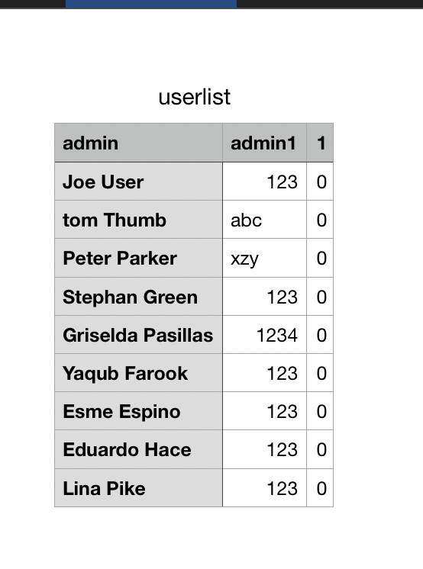

all usernames (admin) and passwords (admin1) for the users in our system.

I. Create Database table. 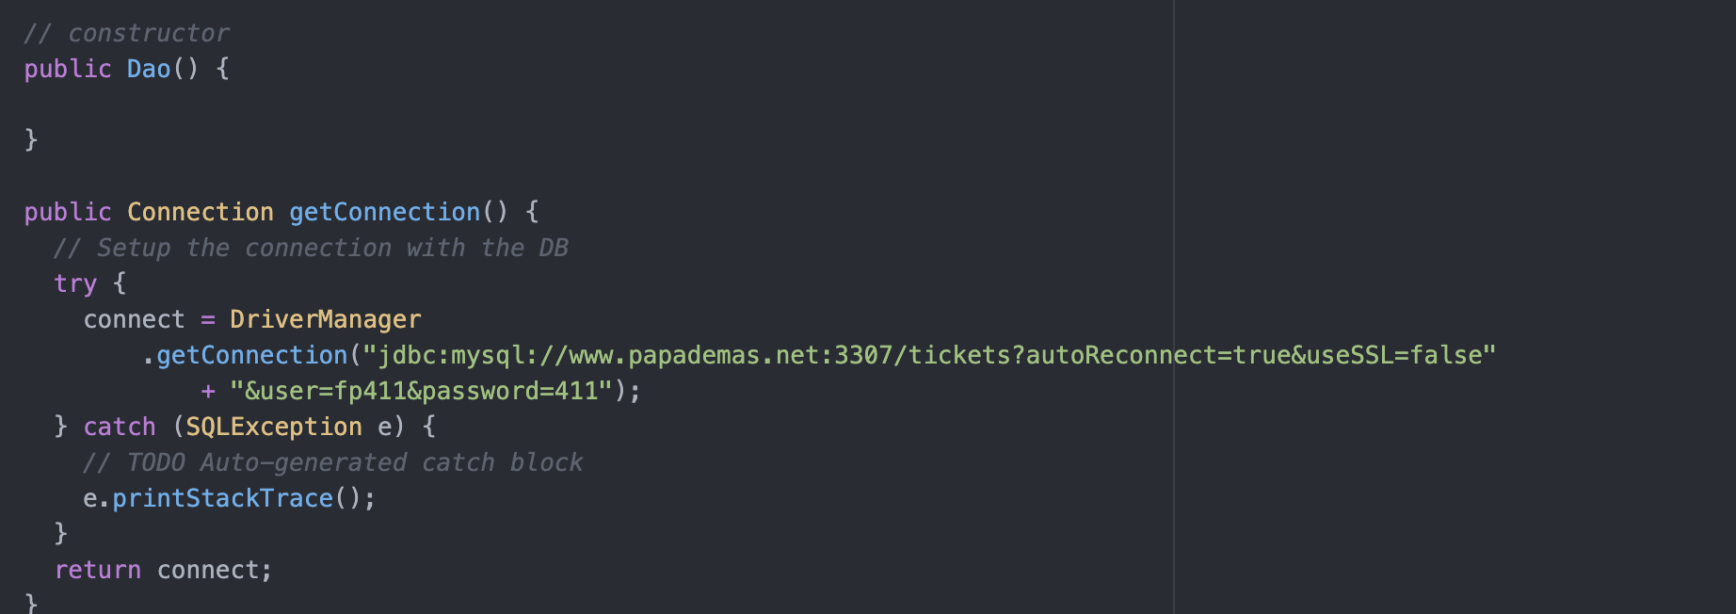

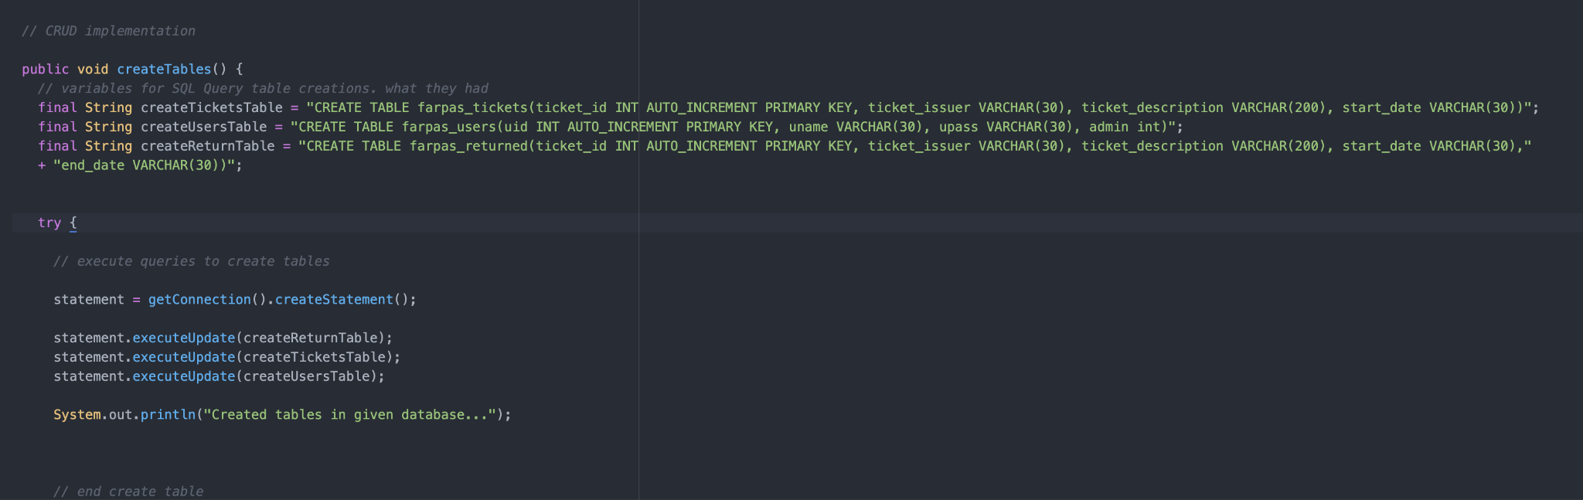

Connecting to the class database and creating our own 3 tables within it

II. Create Java files for interactivity

4 required classes along with an extra one, returned.java, since we worked in a group.



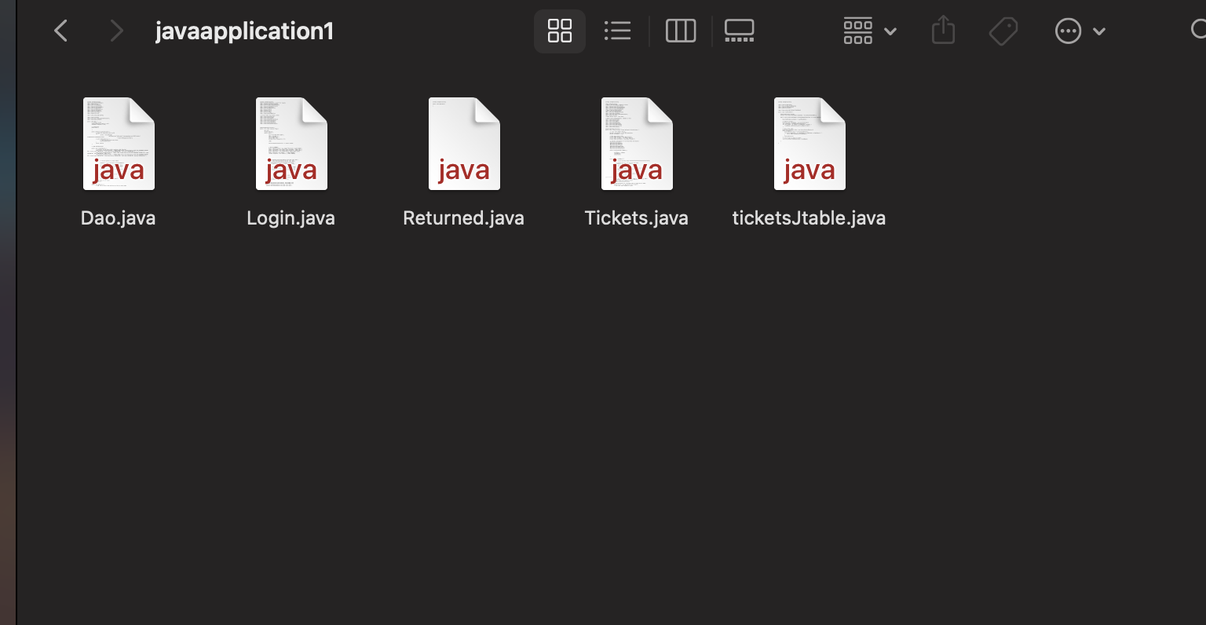

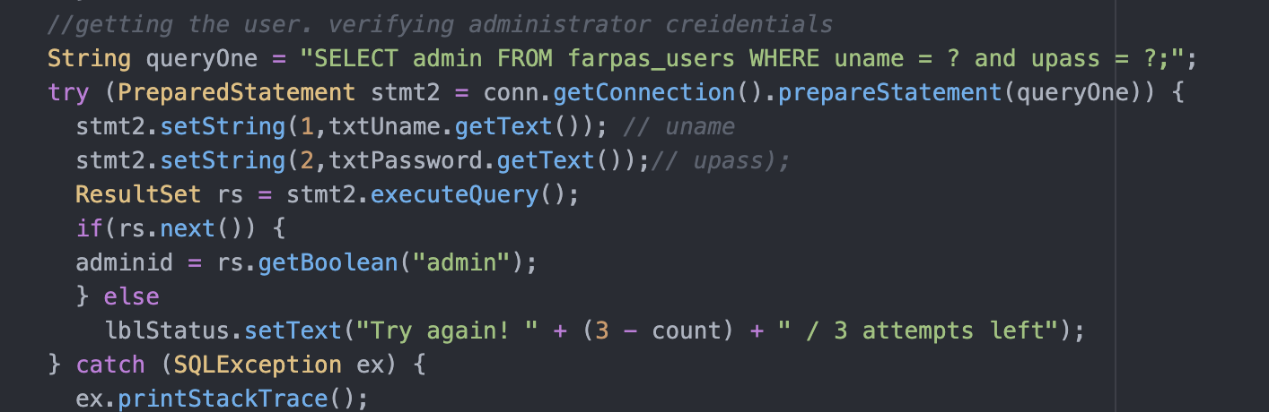

Classes were created to make an interactive GUI that asks users for credentials before making changes to data tables that hold ticket information.

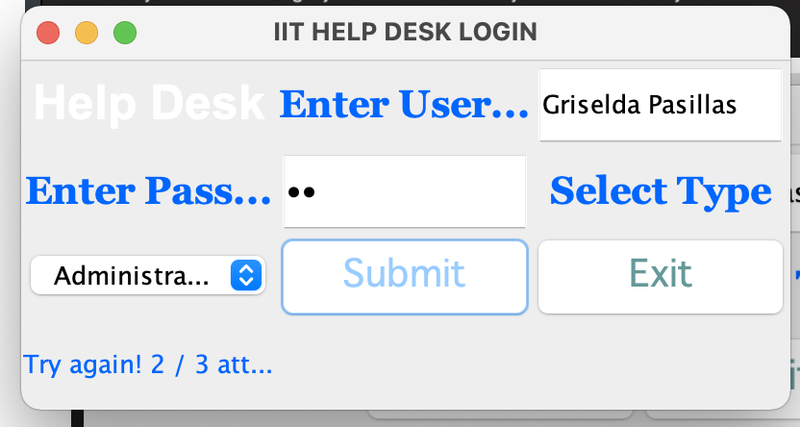

Program alerts users of log in tries. Only 3 attempts can be made for each user.

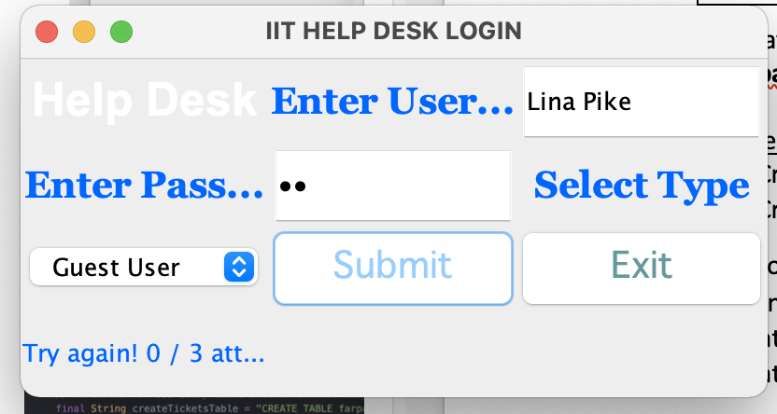

Login in screen for a user who is either an admin or guest user.

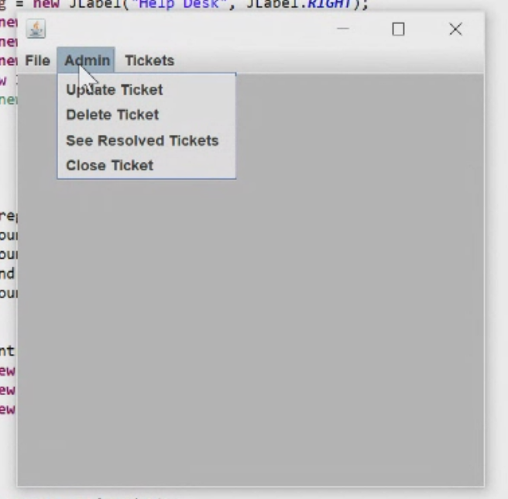

Menu items allow you to update, delete, close tickets and view all documented tickets.

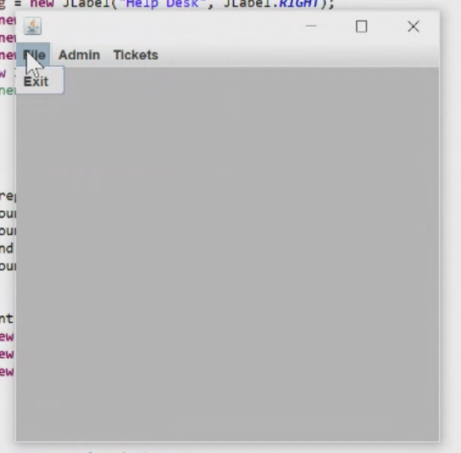Allows you to exit the program through the GUI initial phase and through its menu. 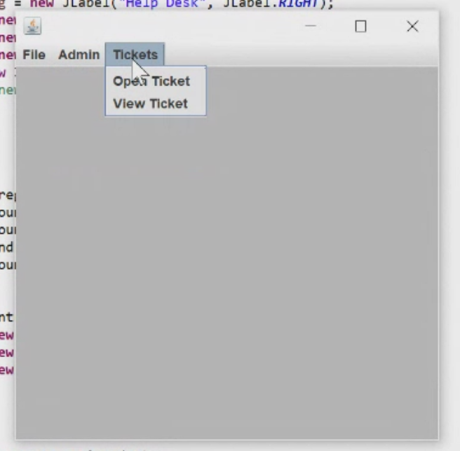Tickets can be created/opened and you can view specific tickets in the database.

Different menu options when a user sign’s in and is prompted on what to do next. Hovering over all 3 options (“File”, “Admin”, “Tickets”) to show what pops up

III. Create a Java file for database connectivity / CRUD implementations

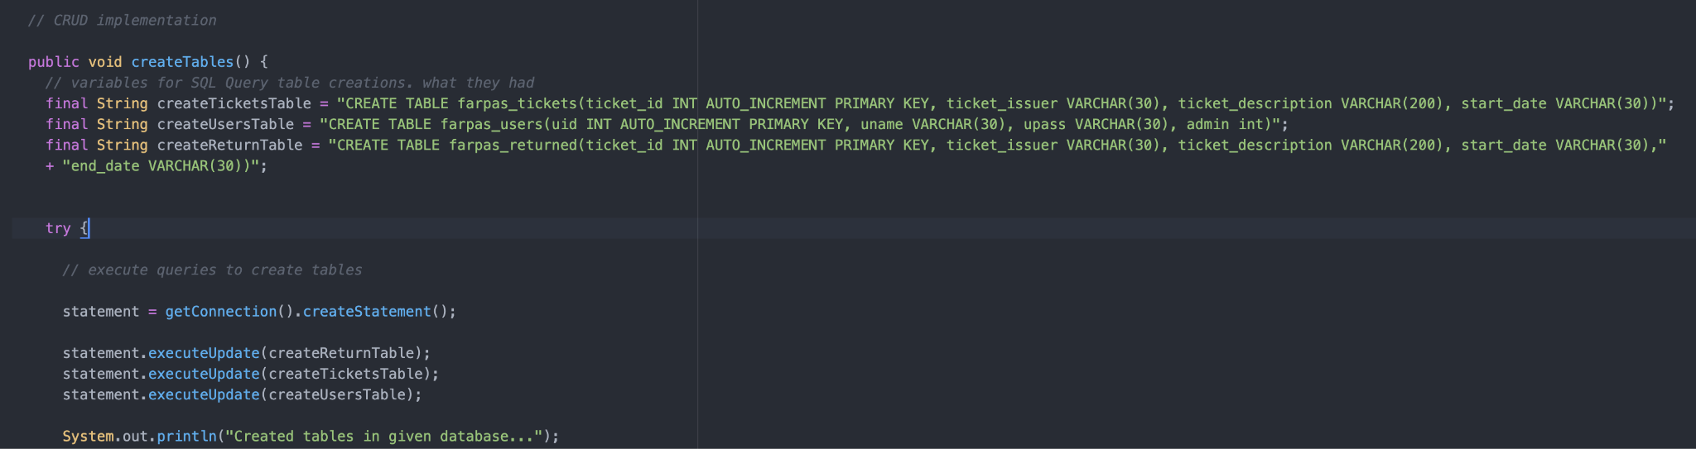

​​IV. Run your app and *snapshot* EACH of the following runtime action for credit

1. Insert at least 10 tickets into the DB table. *Include a record with your name* into the table.

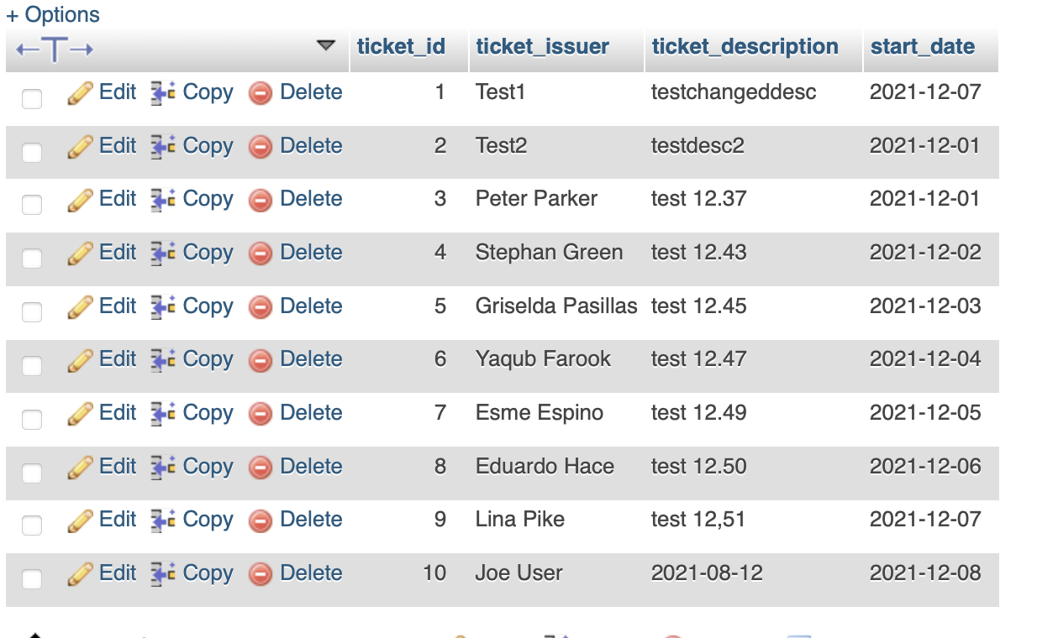

2. Update your record by changing your ticket description.

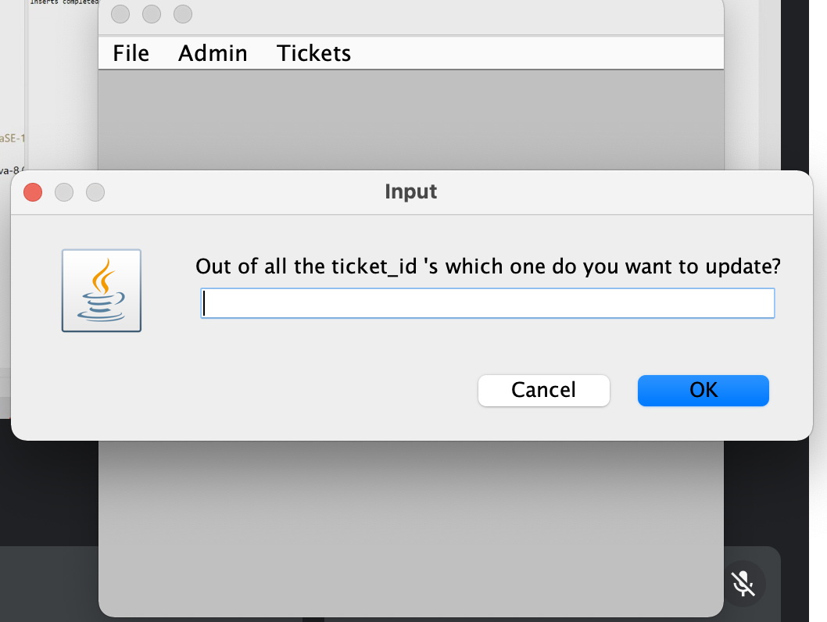Insert description to be made on an existing ticket.

3. Show a view of your updated ticket.

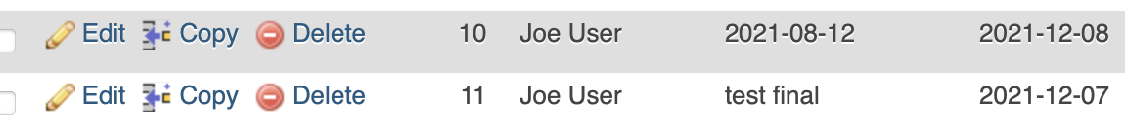

Test description is altered.

4. Delete your ticket from the DB.

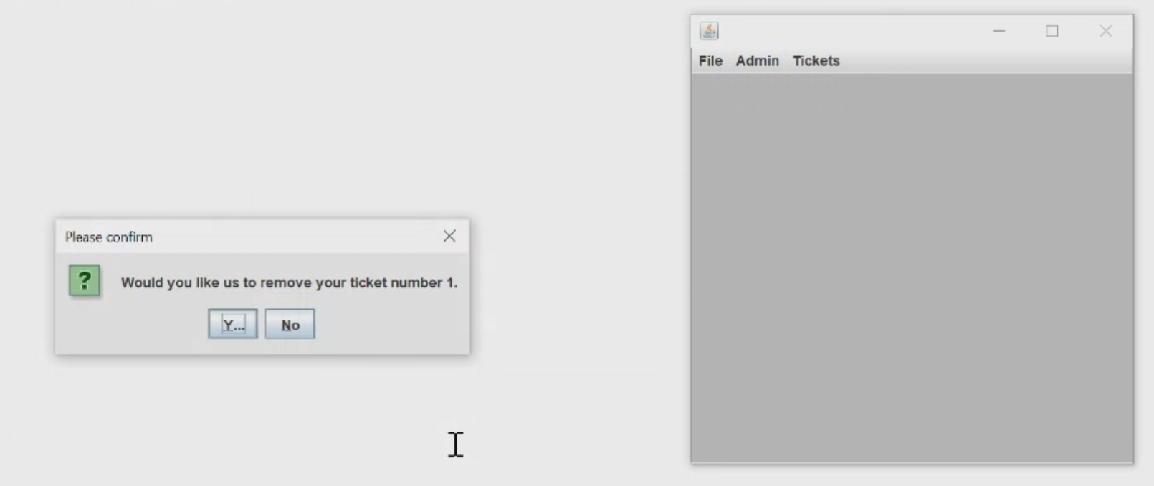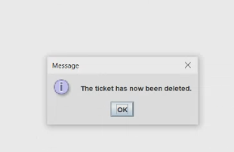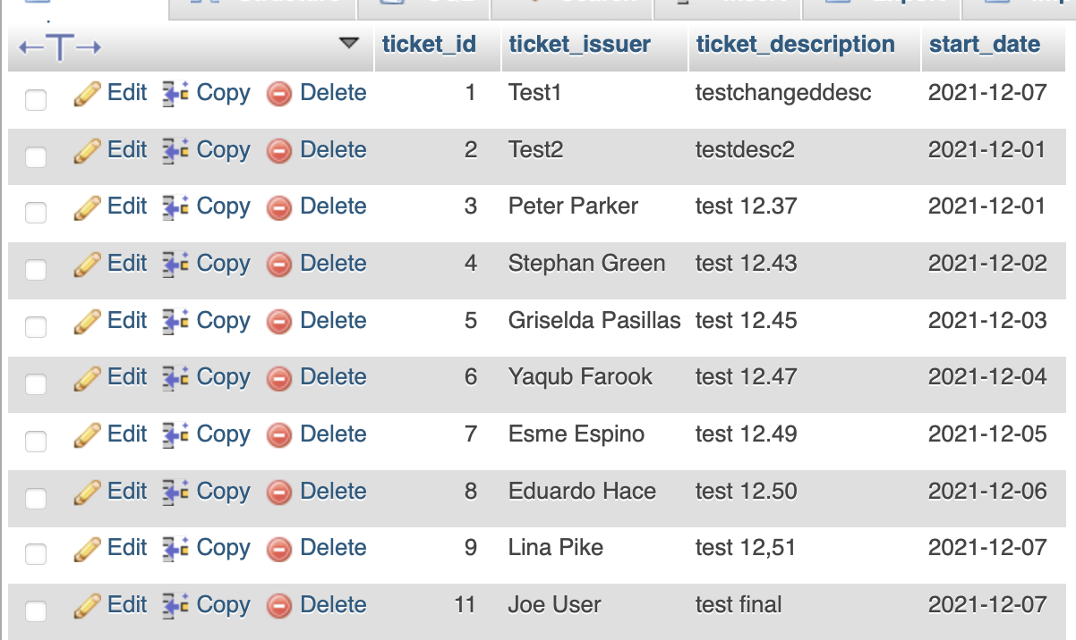All ticket files left in the system after deleting ticket 10.

5. Close any two existing tickets.

The project allows you to close any ticket of your choice by including the ticket id.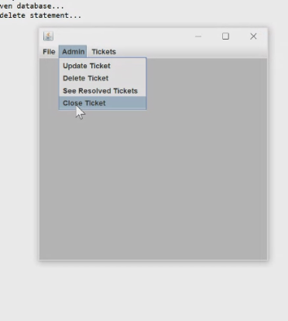

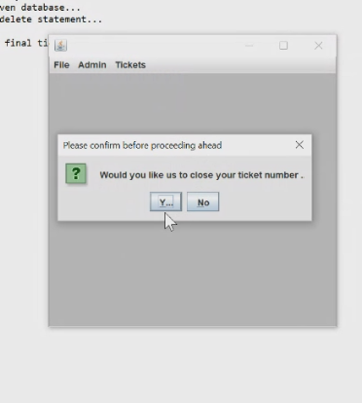 Program presents the option to close the existing ticket in the system or to leave it in the system.

6. Lastly, show a table view of all of your tickets.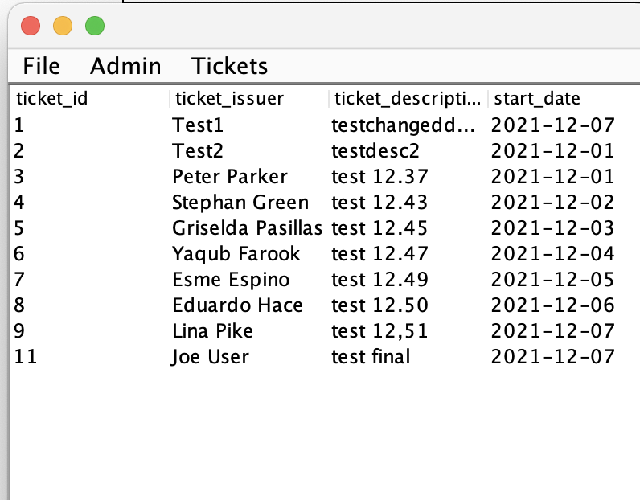

Dated tickets available with descriptions